**Project 2: Marketing Campaign Effectiveness**

**Project Title:** Marketing Campaign Effectiveness Dashboard

**Objective:** To evaluate and visualize the effectiveness of marketing campaigns using Python for data analysis, SQL for querying, and Power BI for reporting.

**Steps:**

1. Use SQL to collect marketing campaign data from multiple sources.
2. Use Python (Pandas) to clean and merge the data.
3. Use Python to calculate key metrics like conversion rates, ROI, and CPA.
4. Import the processed data into Power BI.
5. Design visualizations such as funnel charts, bar charts, and KPI indicators in Power BI.
6. Add interactive elements like filters and drill-downs.

**Expected Outcome:** An interactive dashboard that provides insights into campaign performance, ROI, and effectiveness by channel and date.

Task: Clean & Merge Data: We utilized Python’s Pandas library to clean and merge the collected data. This process involved correcting any inconsistencies, handling missing values, and consolidating data from different sources to create a unified and accurate dataset.

Conversion Rate helps assess how effective the campaign is in turning clicks into conversions.

**CPA (Cost Per Acquisition)**: Computed as Cost / Conversions, which measures the cost incurred for each conversion, helping evaluate the cost-effectiveness of the campaigns.

**ROI (Return on Investment)**: Calculated as ((Revenue - Cost) / Cost) * 100, providing insights into the profitability of each campaign by showing the percentage return relative to the investment.

**Revenue**: Estimated as Conversions * 20 to represent the total earnings from each campaign, which helps in assessing the financial success.

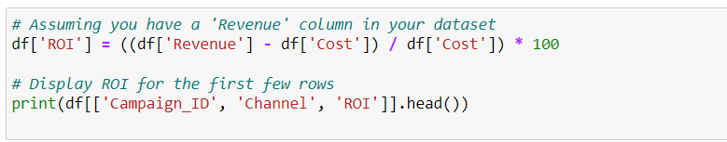

Once all the task and calculation is completed now we have downloaded the file with the given code and this dataset is set to be uploaded in Power BI for the dashboard.

Task 4 & 5:

Create a power BI Dashboard with the Marketing Dataset:

As mentioned I have included filters, pie chart, donut chart, line chart etc to showcase the data.

Below are the screenshots of showcasing the use of Slicer to get the details of only required channels:

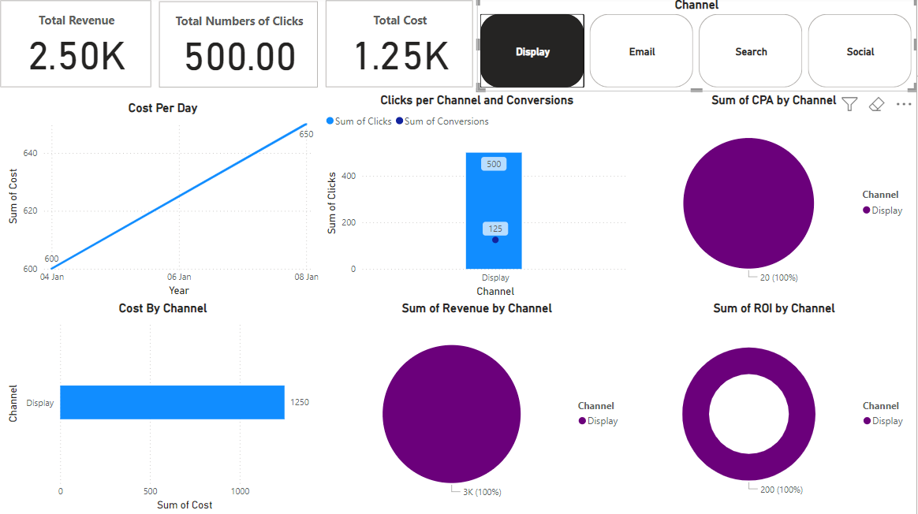

Link for Power BI Dashboard: <https://skilluptech-my.sharepoint.com/:u:/g/personal/gouravs_skillup_online/Ef2o3Te43blBjmhV_84GkGwBvGOkbMTCr9MGzwtbdfnE_Q?e=cOlJMe>